Abstract— Cambodia has been designated as one of the most vulnerable countries to climate change. This paper examines the extent of these changes and its accompanying effects. Using the publically available NCEP Reanalysis II, CSIRO, and five other CMIP5 models, we calculate multi-model means to time the beginning of the monsoon in Cambodia, map the areas that are most affected and also project the precipitation rate and temperature into the future. We account for inherent variability and biases within the models by comparing them. All models mark the beginning in between the fifteenth and the seventeenth week of the year. An average increase of three to five degrees Celsius in the yearly average temperature is expected for all of Cambodia by 2060-2080. Although the General Circulation Models (GCM) show differing values for the change in precipitation, the general trend appears that the wet seasons will have more precipitation.
CRSJ Template for One-Page Papers
First A. Author, Second B. Author, Jr., and Third C. Author

Methods
Climate data was pulled from the Commonwealth Scientific and Industrial Research Organisation (CSIRO) MK 3.6.0, Coupled Model Intercomparison Project Phase 5 and the National Center for Environmental Prediction (NCEP) Reanalysis II (Kanamitsu, M, et al, 2002) datasets.
From the data, multi-model means were computed for both the past and the future. The variables considered were max temperature and precipitation rate. Afterwards, we plotted the rate of precipitation on a weekly basis over all of the years in each dataset and by looking at a rapid increase in the rate, we were able to calculate the onset of the monsoon. We displayed the result in a boxplot to account for outliers.

results
The graph above shows that

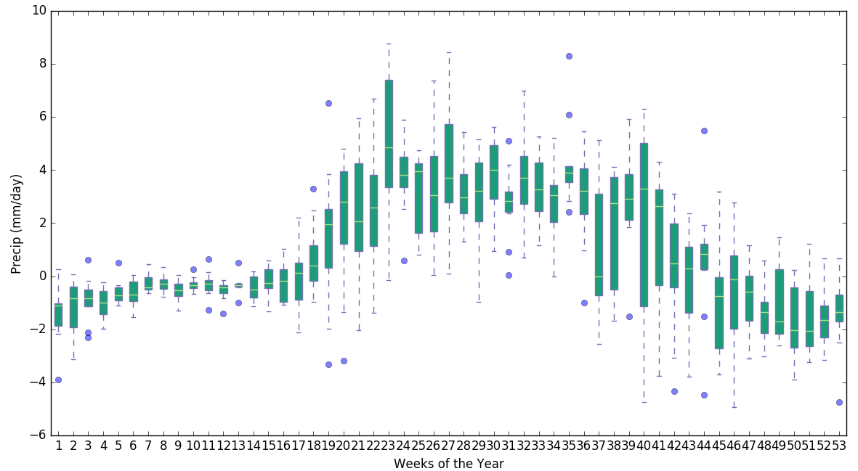
- Difference in weekly precipitation in 2045-2065 relative to 1985-2005

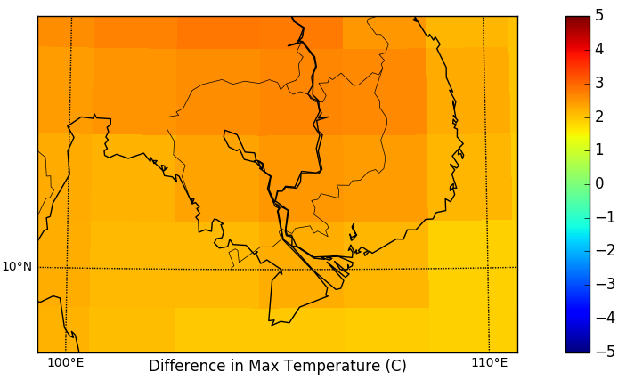
Figure Labels: Use 8 point Times New Roman for Figure labels. Use words rather than symbols or abbreviations when writing Figure axis labels to avoid confusing the reader. If including units in the label, present them within parentheses. Label axes with units and measurement. In the example, write “Magnetization (A/m)”, not just “A/m”. Do not label axes with a ratio of quantities and units. For example, write “Temperature (K)”, not “Temperature/K.”

Conclusion
Define abbreviations and acronyms the first time they are used in the text, even after they have been defined in the abstract. Do not use abbreviations in the title or heads unless they are unavoidable [7]. Use SI units.
- Difference in Mean Max Temperature in 2045-2065 Relative to 1985-2005
You will need to determine whether or not your equation should be typed using either the Times New Roman or the Symbol font (please no other fonts). To create multileveled equations, it may be necessary to treat the equation as a graphic. Equation numbers, within parentheses, are to be
Acknowledgment
Put sponsor acknowledgments in the footnote. Upload your files to http://crsj.org/submit and submit the form by December 15th, 2015. Thank you for submitting to the 2016 Columbia Research Scholars Journal.
References
- G. O. Young, “Synthetic structure of industrial plastics (Book style with paper title and editor),” in Plastics, 2nd ed. vol. 3, J. Peters, Ed. New York: McGraw-Hill, 1964, pp. 15–64.
- W.-K. Chen, Linear Networks and Systems (Book style). Belmont, CA: Wadsworth, 1993, pp. 123–135.
- H. Poor, An Introduction to Signal Detection and Estimation. New York: Springer-Verlag, 1985, ch. 4.
- Y. Yorozu, M. Hirano, K. Oka, and Y. Tagawa, “Electron spectroscopy studies on magneto-optical media and plastic substrate interfaces (Translation Journals style),” IEEE Transl. J. Magn.Jpn., vol. 2, Aug. 1987, pp. 740–741 [Dig. 9th Annu. Conf. Magnetics Japan, 1982, p. 301].
- S. Chen, B. Mulgrew, and P. M. Grant, “A clustering technique for digital communications channel equalization using radial basis function networks (Periodical style),” IEEE Trans. Neural Networks, vol. 4, pp. 570–578, July 1993.

 F. A. Author is with the National Institute of Standards and Technology, Boulder, CO 80305 USA (corresponding author to e-mail: author@ boulder.nist.gov). T. C. Author is with the Electrical Engineering Department, University of Colorado, Boulder, CO 80309 USA, on leave from the National Research Institute for Metals, Tsukuba, Japan (e-mail: author@nrim.go.jp).

